HW5 Report for Math/CS 471

Xiaomeng Li and Jeff Sadowski

11/12/2017

**Abstract**

This is the HW5 Report. First, the report will give a brief introduction of Math background. Second, the report will outline the procedure and methods I used. Third, I will introduce the data results and try to analyze and discuss them. In the end, I will give a conclusion about this Math problem. This time I use Microsoft Word to write this report.

**Introduction**

This homework describes a simulation of angry birds. Using Runge-Kutta to model and simulate the flocking behavior of birds in a two-dimensional space, the homework presents a dynamical situation modeling of societal and scientific problem.

**Procedure and Methods**

Motivation: Derive a set of ODEs to describe the flocking behavior of a flock of N birds.

1. Modeling

Let $B_{k}\left(t\right)=\left(x_{k}\left(t\right),y_{k}\left(t\right)\right)$ be the location of the $k$-th birdat time t, where k=1, 2 ,..., N. $B_{1}(t)$ is the location of the bird leader who is only effected by the bird feeder at $C_{k}\left(t\right)=\left(x_{c}\left(t\right),y_{c}\left(t\right)\right)$. At any instance of time $B_{1}\left(t\right)$ will be changing with ODE equation:

$$B_{1}^{'}\left(t\right)= γ_{1}(C(t)-B_{1}\left(t\right))$$

Where $γ_{1}>0$ is a positive constant whose magnitude is decided by us. The rest of the birds try to stay close to the leader, therefore, they are governed by

$B_{k}^{'}\left(t\right)= γ_{2}(B_{1}\left(t\right)-B_{k}\left(t\right))$, $k=2, …, N$

Where $γ_{2}>0$ is also a positive constant whose magnitude is decided by us.

In order to maintain the safety of the flock the birds try to be as close as possible to the center if the flock, which is denoted by $\overline{B(t)}=\frac{\sum_{k=1}^{N}{B_{k}\left(t\right)}}{N}$. This can be described by a flocking force that holds the birds together:

$F_{k}^{fl}\left(t\right)= κ( \overline{B(t)}-B_{k}\left(t\right))$, $k=2, …, N$

Where $κ>0$ is also a positive constant whose magnitude is decided by us. This flocking force can be added to the right hand side of the ODEs system.

If the birds get too close to each other there will be a strong repelling force. If the $k$-th bird $B_{k}$ is repelled by its $L$ closest neighbors we add to the right hand sides

$F_{k}^{rep}\left(t\right)$ = $\sum_{l=1}^{L}{ρ\frac{(B_{k}\left(t\right)- B_{l}\left(t\right)}{{(B_{k}\left(t\right)- B_{l}\left(t\right))}^{2}+δ}}, k=2, …, N$

Where $ρ>0, δ>0$ which are decided by us. In this homework, I will also define a predator whose function is very similar to the bird feeder mentioned before. Only this time it will affect every bird in the following way.

$$F_{n}^{pre}\left(t\right)= γ_{3}\left(B_{n}\left(t\right)-P\left(t\right)\right), n=1, 2, …, N$$

Where $γ_{3}>0$ which is decided by us. I will also introduce a smelly bird who always wants to be at the center of the flock. In fact, in this smelly bird case, I will use a different repelling force coefficient $ρ2$, which is just for this smelly bird since the repelling force from him is really large. The repelling force coefficient of other birds will stay the same as $ρ1.$

1. Computation

With every bird’s initial locations chosen by us, we can have $B_{k}\left(0\right)=\left(x_{k}\left(0\right),y_{k}\left(0\right)\right), k=1,2, …, N.$ I use fourth order Runge-Kutta method (RK4) for the analysis of the leader bird. Then I use RK1 for others because I did not see any functions of the others who are directly using time function itself, but instead using time index. The computation is completed by MATLAB.

**Results and Discussion**

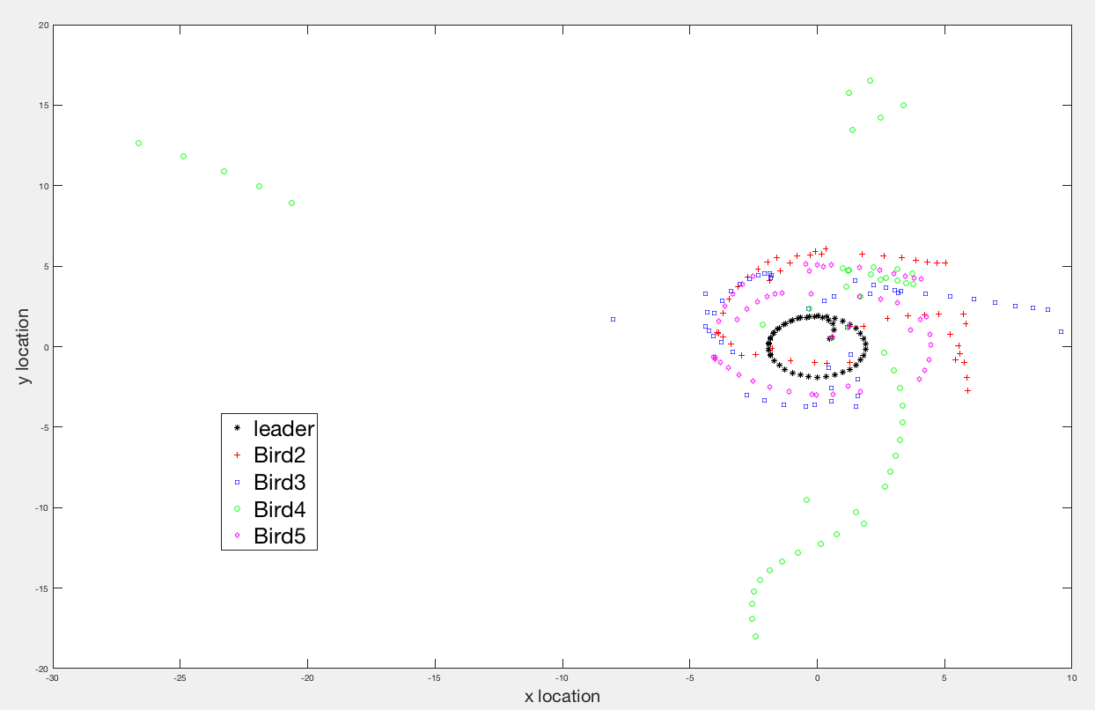

Figure 1: Plot of one bird leader and four other birds.

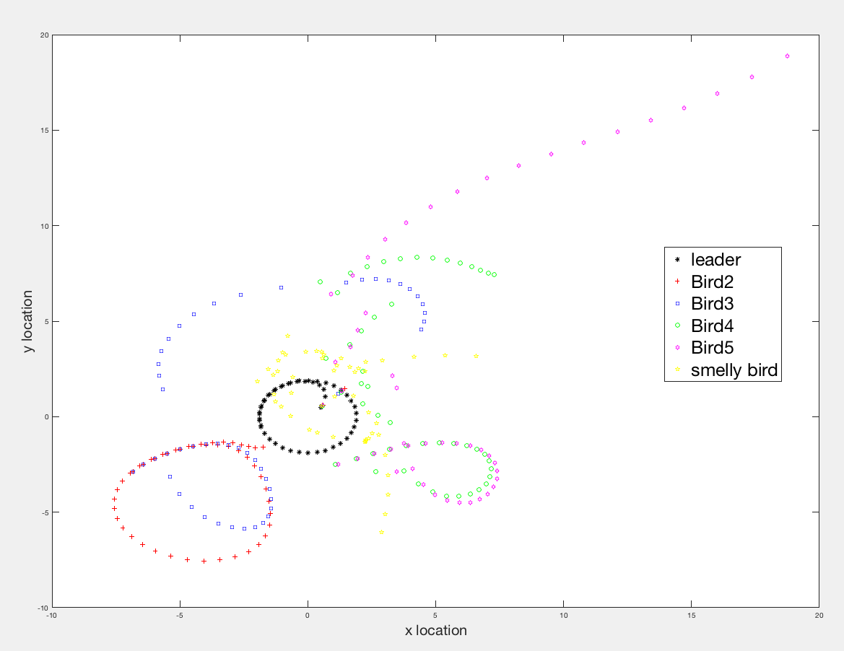

Figure 2: Plot of one bird leader, four other birds and one smelly bird.

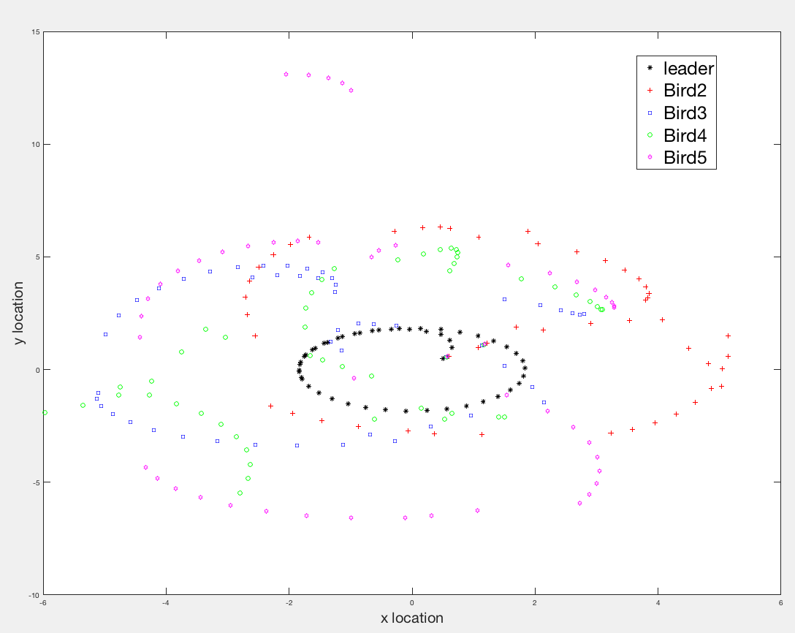

Figure 3. Plot of one bird leader, four other birds who all of five of them are effected by a predator.

Discussion of results:

1. System of ODEs:

$$B_{1}^{'}\left(t\right)= γ_{1}(C(t)-B_{1}\left(t\right))$$

$B_{k}^{'}\left(t\right)= γ_{2}\left(B_{1}\left(t\right)-B_{k}\left(t\right)\right)+F_{k}^{fl}\left(t\right){ + F}_{k}^{rep}\left(t\right)$, k = 2, 3, … , N

Basically, this equation describes every bird’s location $B_{k}\left(t\right)$ and at every moment the forces that are applied on them $B_{k}^{'}\left(t\right)$. Flocking force, repelling force and leader attraction force happen to other birds while the leader birder only gets affected by feeder $C(t)$.

Ex: when $x_{c}> x_{1}$, it means the x coordinate of feeder is not the same as the x coordinate of leader, which will produce a force for leader to fly to feeder. Therefore, other birds will also fly since they are all affected by the leader.

1. Different parameters impact the behavior of the flock.

Fig 1 shows what it would be like when $C_{k}\left(t\right)=\left(2 ×\cos{(t)},2×\sin{(t)}\right)$ with five birds. Fig 4 shows what it would be like when $C_{k}\left(t\right)=\left(0 ×\cos{(t)},0×\sin{(t)}\right)$ with same five birds. It is easy to tell that when leader is no longer moving. The other birds are only affected by themselves: i.e. their location will still be changing through time, but it will change in a certain pattern. Comparing Fig. 5 and Fig. 1 with 2 birds and 5 birds I think when the quantity of the birds gets bigger, the flocking force gets bigger too. That is why it will lead birds’ flying behavior to a more compact behavior. The behavior in Fig 5 looks quite loose because of a lack of flocking force.

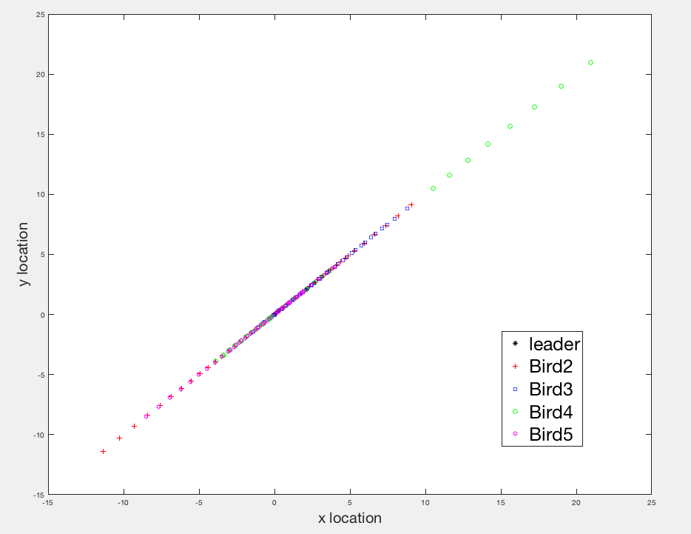

Figure 4: Plot of one bird leader and four other birds ($C_{k}\left(t\right)=\left(0 ,0\right)$).

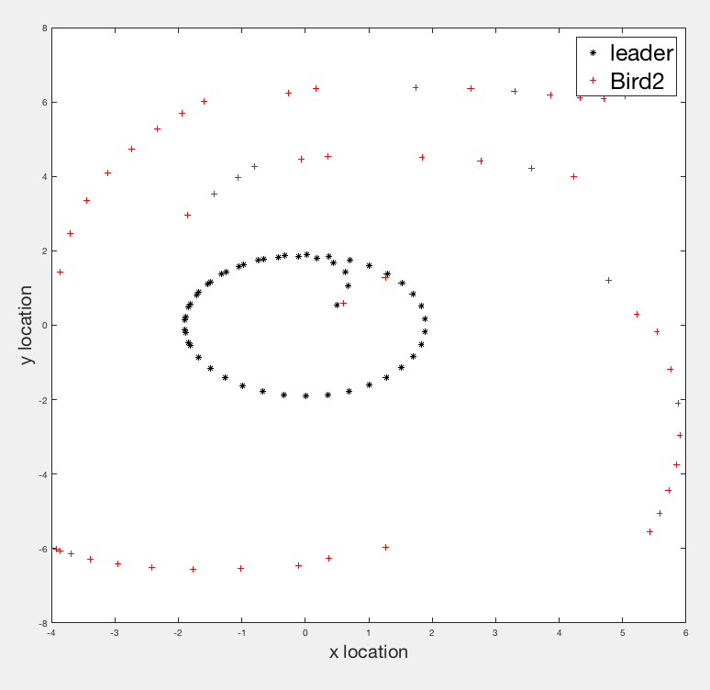

Figure 5: Plot of one bird leader and one other bird.

1. Flock diameter = $\frac{\sum_{i=1}^{N}{D_{i}}}{N}$, where $D_{i}$ is the distance at each time step t Bird i’s distance to the center of the flock. Observing from the video, I think the distances of every bird to their centers are changing over time though it gets bigger or smaller through the whole process. It does not converge.
2. Please see the folder called “Smelly Bird”. The smelly bird tends to stay in the center and keep a distance from others. The basic logic is that smelly bid gives a much bigger repelling force to others therefore it will bring a much bigger coefficient $ρ2$, whereas the smelly bird still uses $ρ1$ because it will not repel itself. Notice smelly bird is not counted in $2, …, N.$

$F_{smelly}^{rep}\left(t\right)$ = $\sum_{l=1}^{L}{ρ1\frac{(B_{k}\left(t\right)- B_{l}\left(t\right)}{{(B_{k}\left(t\right)- B_{l}\left(t\right))}^{2}+δ}}, k=smelly bird$

$F_{k}^{rep}\left(t\right)$ = $\sum_{l=1}^{L}{ρ2\frac{(B_{k}\left(t\right)- B_{l}\left(t\right)}{{(B_{k}\left(t\right)- B_{l}\left(t\right))}^{2}+δ}}, k=2, …, N$

1. Please see the folder called “predator”. The basic logic is outlined below:

$$B_{1}^{'}\left(t\right)= γ_{1}\left(C\left(t\right)-B_{1}\left(t\right)\right)+F_{1}^{pre}\left(t\right)$$

$B_{k}^{'}\left(t\right)= γ_{2}\left(B_{1}\left(t\right)-B_{k}\left(t\right)\right)+F_{k}^{fl}\left(t\right){ + F}_{k}^{rep}\left(t\right)+F_{k}^{pre}\left(t\right)$, k = 2, 3, … , N

$$F_{n}^{pre}\left(t\right)= γ_{3}\left(B_{n}\left(t\right)-P\left(t\right)\right), n=1, 2, …, N$$

where $P\left(t\right)$ is the location of predator. Predator’s location will be changing through time which is similar to $C\left(t\right)$. It will affect every bird in the system.

**Conclusions**

This homework describes the behavior of a flock of birds. Different cases such as the number of birds, the dynamic situations of feeder will have an impact on the flying behavior of the birds. RK4 is implemented for the behavior of the leader bird. Other birds’ ODE equations are implemented with RK1. The birds’ own behavior, such as the case of “smelly bird”, will also influence the path of the whole bird flock.